**UNIT 3 & 4 CHEM Name: _______________**

**TOPIC 3:**   
TITRATIONS

Syllabus dot-points

**Science Understanding:**

* volumetric analysis methods involving acid-base reactions rely on the identification of an equivalence point by measuring the associated change in pH, using appropriate acid-base indicators or pH meters, to reveal an observable end point
* data obtained from acid-base titrations can be used to calculate the masses of substances and concentrations and volumes of solutions involved

**Science Investigation Skills:**

* identify and distinguish between random and systematic errors, and estimate their effect on measured results

**Timetable:**

|  |  |  |  |  |
| --- | --- | --- | --- | --- |
| **Wk** | **Monday P1** | **Tuesday P2** | **Wednesday P3** | **Thursday P5** |
| 1 |  |  | Demo of NaOH vs HCℓ titration (pg 2-3)  Standard solutions (pg 4-5)  **HW: Start calculations  pg 24-39** | **Experiment:** Making primary standard (pg. 6-7)  **Weekend HW: Finish calculations pg 24-39** |
| 2 | **Experiment:** Standardising HCℓ solution (pg. 8-9)  **HW: Extended response preparation** | **Extended response task** | Equivalence point and end point. Selecting appropriate indicators. (pg 10-13)  **HW: Read ‘rinsing’, ‘errors’, ‘dilutions’  (pg. 14-18)** | **Experiment:** Diluting household ammonia and titrating against NH3  **Weekend HW: Exploring Chem pg. 60-63 Start past exam questions** |
| 3 | Chance to finish off calculations for NH3 experiment and seek help for difficult problems.  **Should be almost finished all HW and past exam Qs by this stage!!** | **Titrations Practical Test *(half of class)*** | **Titrations Practical Test *(other half of class)*** | **Titrations Written Test** |

**UNIT 3 & 4 CHEM Name: _______________**

**TOPIC 3:**   
TITRATIONS

Syllabus dot-points

**Science Understanding:**

* volumetric analysis methods involving acid-base reactions rely on the identification of an equivalence point by measuring the associated change in pH, using appropriate acid-base indicators or pH meters, to reveal an observable end point
* data obtained from acid-base titrations can be used to calculate the masses of substances and concentrations and volumes of solutions involved

**Science Investigation Skills:**

* identify and distinguish between random and systematic errors, and estimate their effect on measured results

**Timetable:**

|  |  |  |  |  |
| --- | --- | --- | --- | --- |
| **Wk** | **Tuesday P1** | **Wednesday P2** | **Thursday P3** | **Friday P5** |
| 1 |  |  | Demo of NaOH vs HCℓ titration (pg 2-3)  Standard solutions (pg 4-5)  **HW: Start calculations  pg 24-39** | **Experiment:** Making primary standard (pg. 6-7)  **Weekend HW: Continue calculations pg 24-39**  **Prepare for extended response** |
| 2 | **Extended Response Task** | **Experiment:** Standardising HCℓ solution (pg. 8-9)  **HW: Finish calculations pg 24-39** | Equivalence point and end point. Selecting appropriate indicators. (pg 10-13)  **HW: Read ‘rinsing’, ‘errors’, ‘dilutions’  (pg. 14-18)** | **Experiment:** Diluting household ammonia and titrating against NH3  **Weekend HW: Exploring Chem pg. 60-63 Start past exam questions** |
| 3 | Chance to finish off calculations for NH3 experiment and seek help for difficult problems.  **Should be almost finished all HW and past exam Qs by this stage!!** | **Titrations Practical Test** | **Titrations Written Test** | *Test results /  Exam revision* |

**ACID-BASE TITRATIONS**

Titrations are a method for accurately determining the concentration of a substance.

There are two substances in a titration:

* A substance of known concentration (called a standard solution)
* A substance of unknown concentration

Today your teacher will demonstrate how this procedure could be used to find the concentration of a solution of HCℓ using a standard solution of NaOH.

**

**Step A:**

* A volumetric pipette is rinsed with HCℓ.
* A conical flask is rinsed with distilled water.
* The pipette is used to draw up 20.0 mL of HCℓ, which is then added to the flask
* Two drops of an appropriate indicator is added

**Step B:**

* A burette is rinsed with NaOH solution
* NaOH is added to the burette until it is almost full
* Some NaOH is let out of the tap at the bottom to remove any air bubbles
* The initial volume of the burette is read
* The conical flask is placed under the burette

**Step C:**

* NaOH is added from the burette until the indicator has a permanent colour change
* The final volume of the NaOH solution is read

**Measurements:**

Titrations are normally repeated until you have three measurements that are concordant (‘concordant’ means ‘in agreement’ or ‘consistent’). This normally means three titre volumes that are within 0.1 mL of each other. Any inconsistent results are **not** included in the average titre volume.

|  |  |  |  |  |
| --- | --- | --- | --- | --- |
|  | **Trial 1** | **Trial 2** | **Trial 3** | **Trial 4** |
| Initial volume (mL) |  |  |  |  |
| Final volume (mL) |  |  |  |  |
| Titre volume (mL) |  |  |  |  |

**Average volume of NaOH:** ______________ mL

**Concentration of NaOH solution:** ____________ mol L-1 *(from label on bottle)*

1. Calculate the moles of NaOH needed to neutralise the HCℓ. **Show working.**

1. The reaction occurring in the conical flask is: HCℓ + NaOH → NaCℓ + H2O

Calculate the moles of HCℓ in the conical flask. **Show working.**

1. Calculate the concentration of the original HCℓ solution. **Show working.**

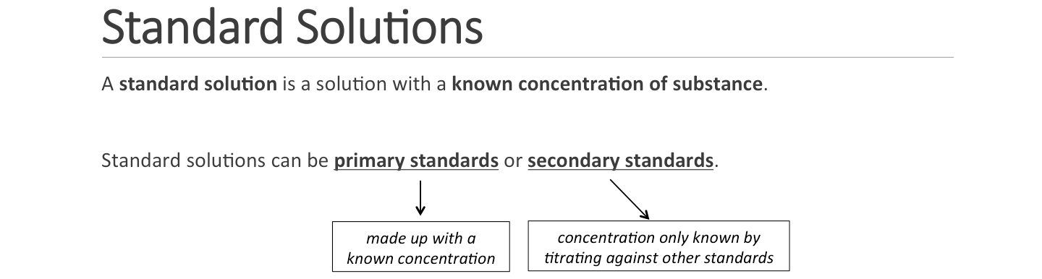

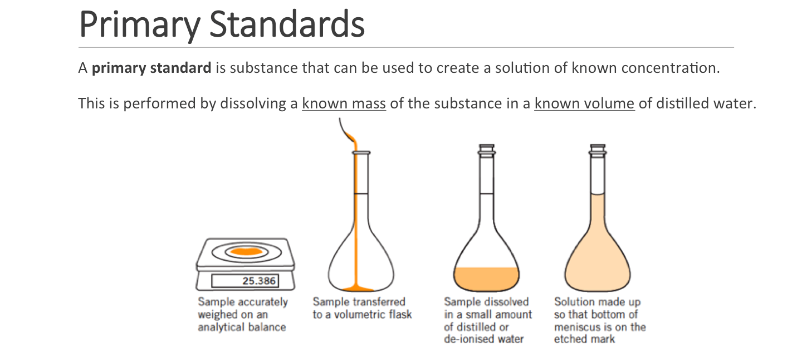

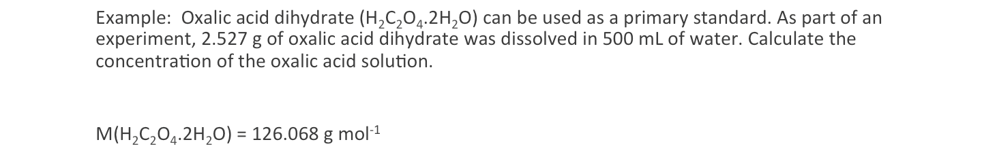

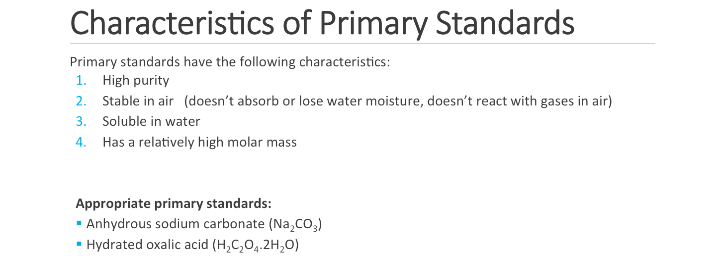

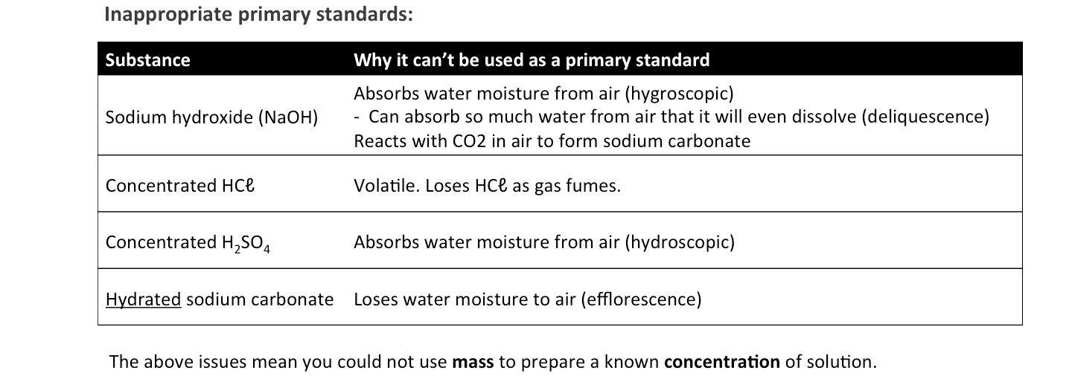

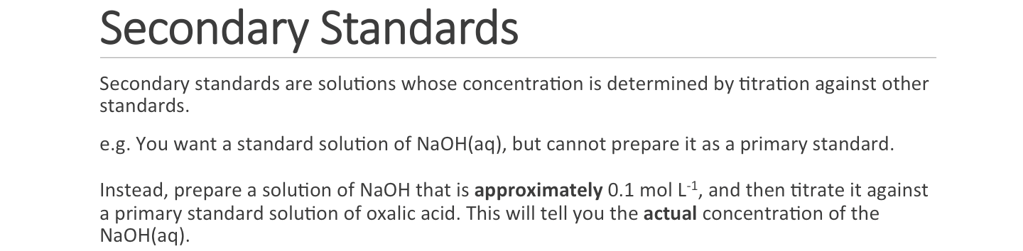

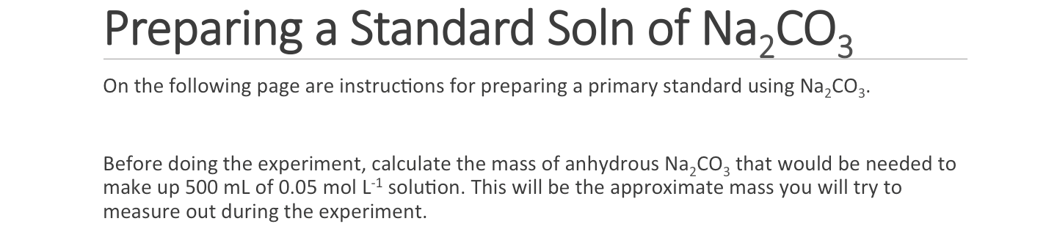

**Experiment: Preparation of a standard sodium carbonate solution**

**Background:**

Standard solutions are solutions whose concentrations are accurately known. Volumetric techniques rely on accurate measurement of quantities. Mass and volume are the usual quantities measured. This experiment is the first in a series that prepares some standard solutions.

Prepare a solution of   
~0.1 mol L-1 HCℓ.   
Standardise using Na2CO3

Use HCℓ secondary standard to find conc. of NH3 in household ammonia

Prepare a solution of 0.05 mol L-1 Na2CO3 (primary standard)

In this experiment you will prepare 500 mL of approximately 0.05 mol L-1 Na2CO3 solution whose concentration is accurately known.

**Equipment:**

* Mass balance
* Volumetric flask (500 mL)
* Oven
* Desiccator
* Beaker (250 mL)
* Washbottle
* Storage bottle (approximately 500 mL)
* Distilled water
* Anhydrous sodium carbonate (Na2CO3) (~4 g)
* Stirring rod

**Procedure:**

1. **(Before the experiment)** Calculate the mass of anhydrous Na2CO3 required to make up 500 mL of 0.05 mol L-1 solution.  
     
   Answer: ________ g
2. **(Before the experiment)** Your teacher will place the Na2CO3 in an oven at 270 °C for 30 minutes to remove any water, and then leave the anhydrous Na2CO3 in a desiccator to cool.
3. Accurately weigh out into a 250 mL beaker a mass of Na2CO3 approximately equal to that calculated. You should not waste time trying to weigh out exactly the mass calculated. Any value within ±0.5 g of the target will be fine, so long as you correctly record the actual mass used.  
     
    Mass of Na2CO3 used: __________ g
4. Dissolve the solid in ~100 mL of distilled water
5. Transfer this solution to a 500 mL volumetric flask. To ensure that all of the Na2CO3 has been transferred, rinse the beaker several times with about 20 mL portions of distilled water, adding each washing to the volumetric flask.

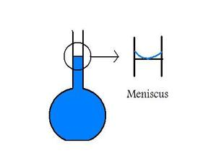

1. Make up the solution to precisely 500.0 mL with distilled water, until the meniscus of the water level is a few cm below the etched line on the flask.   
     
   **Add the last few drops using a plastic pipette to ensure you do not overfill the flask.** **Stop when the meniscus is touching the etched line.**
2. Place the stopper on the flask and invert the flask a few times to thoroughly mix the solution
3. Calculate the concentration of your standard solution:

1. Use a small amount of the solution to rinse a storage bottle. Then, transfer your solution to the storage bottle. Label it with your name, the type of solution and its concentration.

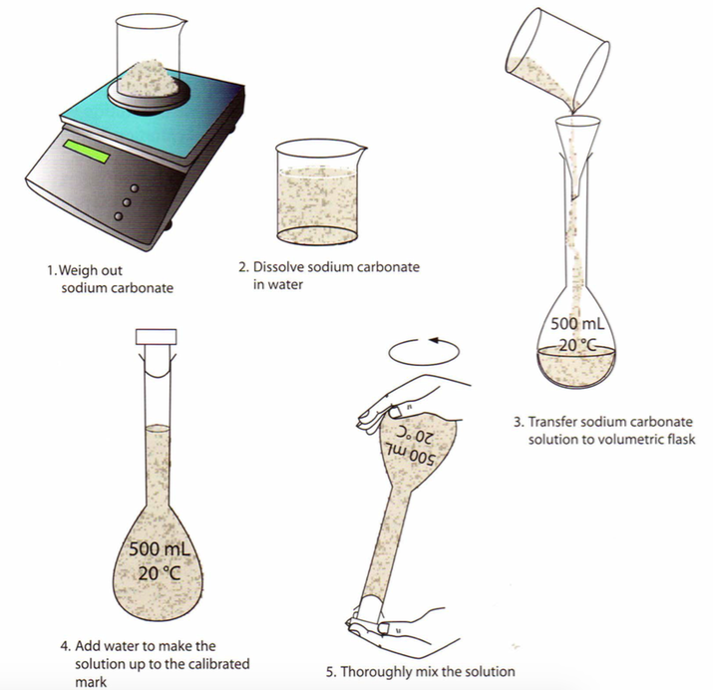

**Experiment: Standardisation of HCℓ solution**

**Background:**

Hydrochloric acid cannot be used as a primary standard. In this experiment you will standardise an approximately 0.1 mol L-1 solution to determine its exact concentration by titration against the standard Na2CO3 solution prepared in the previous experiment. The equation for the reaction is:

2 HCℓ(aq) + Na2CO3(aq) → 2 NaCℓ(aq) + H2O(ℓ) + CO2(g)

Note that **one mole of Na2CO3** reacts with **two moles of HCℓ**.

The carbon dioxide produced in this reaction results in the formation of carbonic acid (H2CO3) and therefore the reaction will have a somewhat acidic pH at the end of the reaction (pH ~3.5). Therefore an indicator that changes colour in this region must be used, such as methyl orange (yellow to red when pH changes from 4.4 to 3.1) or bromophenol blue (blue to yellow for pH change from 4.6 to 3.0).

**Equipment:**

* beakers (2x 100 mL, 1x 50 mL)
* burette and stand
* funnel
* pipette (20 mL)
* pipette filler
* conical flasks (4x 250 mL)
* storage bottle containing approximately 0.1 mol L-1 HCℓ
* storage bottle containing Na2CO3 primary standard from previous experiment
* methyl orange or bromophenol blue indicator (a few drops)
* distilled water (600 mL)

**Procedure:**

1. Label the 100 mL beakers as “Na2CO3” and “HCℓ”.  
   Label the 50 mL beaker as “waste”
2. Place about 100 mL of the standard Na2CO3 solution into the correctly labelled beaker. If the beaker is wet, rinse with a little of the Na2CO3 solution first.
3. Rinse the ‘Rough’ 250 mL conical flask with distilled water, and then rinse a clean 20 mL pipette with some of the Na2CO3 solution. Pipette a 20 mL aliquot of the Na2CO3 solution into the conical flask. Add 2-3 drops of indicator into the flask.

1. Place about 100 mL of HCℓ into a clean beaker. Again, if necessary, rinse the beaker with a little of the HCℓ solution first.
2. Rinse a clean burette with some of the HCℓ and then fill the burette with the solution. Pour some HCℓ into the waste beaker and ensure there are no bubbles in the bottom of the burette.
3. Note and record the level of acid in the burette. Obtain a rough estimate of the titration volume by running acid quickly from the burette while constantly swirling the liquid in the conical flask. Stop delivery of the acid as soon as a permanent colour change is obtained. Note and record the acid level in the burette and determine the approximate volume of acid required.

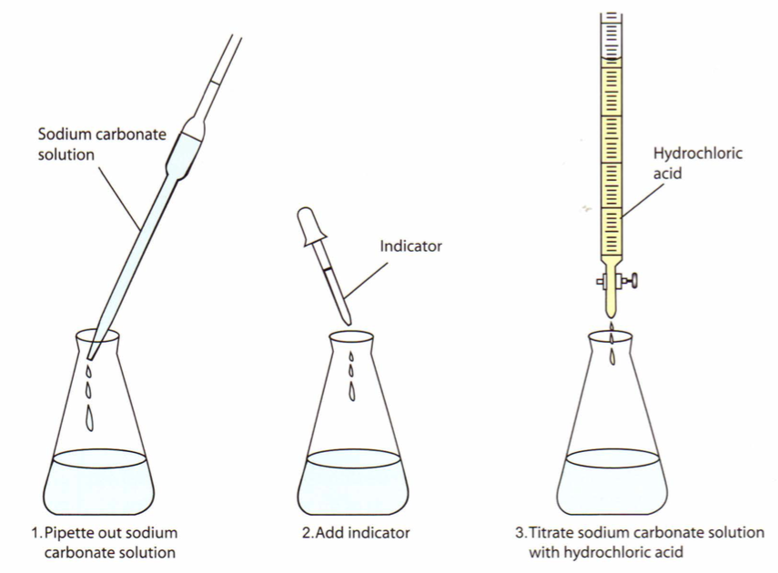

1. Prepare another conical flask containing 20 mL of the Na2CO3 solution and 2-3 drops of indicator. This time add the acid quickly from the burette with constant swirling of the flask, until the volume added is within 2-3 mL of the approximate volume required. Rinse the inside of the conical flask with a jet of water from a wash bottle to return any splashed solution to the bulk. Continue adding acid drop by drop, and with constant swirling, until the addition of one drop is sufficient to produce a permanent colour change. Note and record the level of the acid in the burette at the end point.
2. Repeat the accurate titration with further 20 mL portions of Na2CO3 solution until consistent titration volumes are obtained. These should be within 0.2 mL of each other.

**Results**

|  |  |  |  |  |  |
| --- | --- | --- | --- | --- | --- |
|  | Rough estimate | Accurate titrations | | | |
| 1 | 2 | 3 | 4 (if needed) |
| Initial volume (mL) |  |  |  |  |  |
| Final volume (mL) |  |  |  |  |  |
| Titre volume (mL) |  |  |  |  |  |

**Calculate the concentration of the HCℓ solution:**

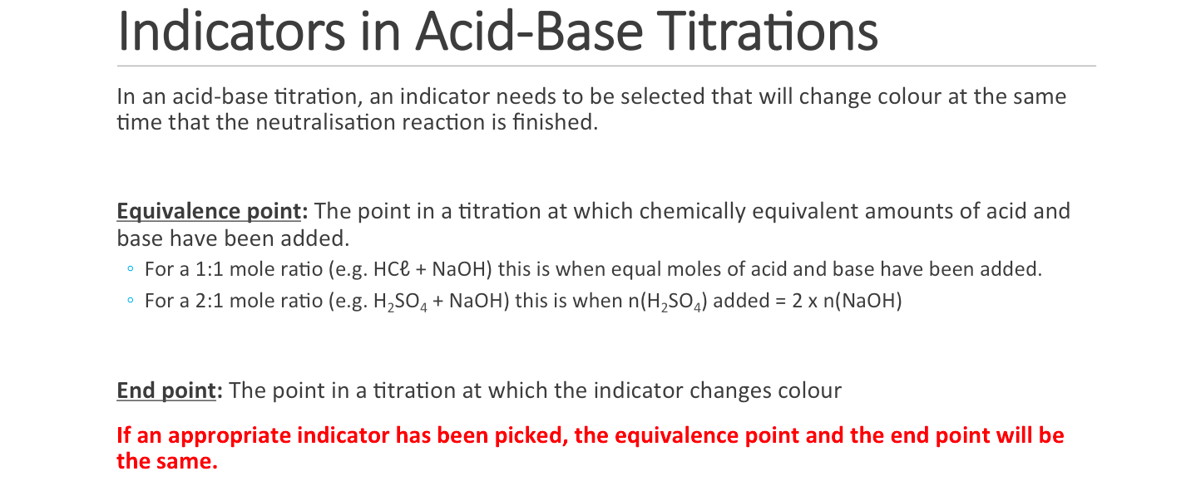

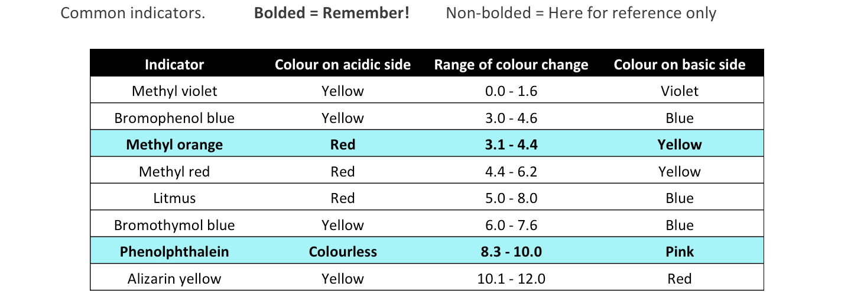

Calculate the change in pH when 0.100 mol L-1 NaOH is added to 20.0 mL of 0.100 mol L-1 NaOH

**Important formulae:** n=cV c=n/V [H+]=Kw/[OH-] [OH-]=Kw/[H+] pH=-log[H+]

|  |  |  |  |  |  |  |  |  |  |
| --- | --- | --- | --- | --- | --- | --- | --- | --- | --- |
| **V(HCℓ) initial** (mL) | **V(NaOH) added** (mL) | **Total volume** (mL) | **n(HCℓ) initial** (mol) | **n(NaOH) added**  (mol) | **n(H+) excess**  (mol) | **n(OH-) excess**  (mol) | **[H+]**  (mol/L) | **[OH-]**  (mol/L) | **pH** |
| 20.0 | 0.0 | 20.0 | 0.00200 | 0.00000 | 0.00200 | – | 0.100 | 1.00x10-13 | 1.00 |
| 20.0 | 5.0 | 25.0 | 0.00200 |  |  | – |  |  |  |
| 20.0 | 10.0 | 30.0 | 0.00200 |  |  | – |  |  |  |
| 20.0 | 15.0 | 35.0 | 0.00200 |  |  | – |  |  |  |
| 20.0 | 19.0 | 39.0 | 0.00200 |  |  | – |  |  |  |
| 20.0 | 19.5 | 39.5 | 0.00200 |  |  | – |  |  |  |
| 20.0 | 19.8 | 39.8 | 0.00200 |  |  | – |  |  |  |
| 20.0 | 20.0 | 40.0 | 0.00200 | 0.00200 | – | – | 1.00x10-7 | 1.00x10-7 | 7.00 |
| 20.0 | 20.2 | 40.2 | 0.00200 |  | – |  |  |  |  |
| 20.0 | 20.5 | 40.5 | 0.00200 |  | – |  |  |  |  |
| 20.0 | 21.0 | 41.0 | 0.00200 |  | – |  |  |  |  |
| 20.0 | 25.0 | 45.0 | 0.00200 |  | – |  |  |  |  |
| 20.0 | 30.0 | 50.0 | 0.00200 | 0.00300 | – | 0.00100 | 5.00x10-13 | 0.0200 | 12.30 |

Graph:

**Change in pH as 0.10 mol L-1 NaOH is added to 20.0 mL of 0.10 mol L-1 HCℓ**

0

1

2

3

13

12

11

10

9

8

7

6

5

4

14

**pH**

|  |  |  |  |  |  |  |  |  |  |  |  |  |  |  |  |  |  |  |  |  |  |  |  |  |  |  |  |  |  |
| --- | --- | --- | --- | --- | --- | --- | --- | --- | --- | --- | --- | --- | --- | --- | --- | --- | --- | --- | --- | --- | --- | --- | --- | --- | --- | --- | --- | --- | --- |
|  |  |  |  |  |  |  |  |  |  |  |  |  |  |  |  |  |  |  |  |  |  |  |  |  |  |  |  |  |  |
|  |  |  |  |  |  |  |  |  |  |  |  |  |  |  |  |  |  |  |  |  |  |  |  |  |  |  |  |  |  |
|  |  |  |  |  |  |  |  |  |  |  |  |  |  |  |  |  |  |  |  |  |  |  |  |  |  |  |  |  |  |
|  |  |  |  |  |  |  |  |  |  |  |  |  |  |  |  |  |  |  |  |  |  |  |  |  |  |  |  |  |  |
|  |  |  |  |  |  |  |  |  |  |  |  |  |  |  |  |  |  |  |  |  |  |  |  |  |  |  |  |  |  |
|  |  |  |  |  |  |  |  |  |  |  |  |  |  |  |  |  |  |  |  |  |  |  |  |  |  |  |  |  |  |
|  |  |  |  |  |  |  |  |  |  |  |  |  |  |  |  |  |  |  |  |  |  |  |  |  |  |  |  |  |  |
|  |  |  |  |  |  |  |  |  |  |  |  |  |  |  |  |  |  |  |  |  |  |  |  |  |  |  |  |  |  |
|  |  |  |  |  |  |  |  |  |  |  |  |  |  |  |  |  |  |  |  |  |  |  |  |  |  |  |  |  |  |
|  |  |  |  |  |  |  |  |  |  |  |  |  |  |  |  |  |  |  |  |  |  |  |  |  |  |  |  |  |  |
|  |  |  |  |  |  |  |  |  |  |  |  |  |  |  |  |  |  |  |  |  |  |  |  |  |  |  |  |  |  |
|  |  |  |  |  |  |  |  |  |  |  |  |  |  |  |  |  |  |  |  |  |  |  |  |  |  |  |  |  |  |
|  |  |  |  |  |  |  |  |  |  |  |  |  |  |  |  |  |  |  |  |  |  |  |  |  |  |  |  |  |  |
|  |  |  |  |  |  |  |  |  |  |  |  |  |  |  |  |  |  |  |  |  |  |  |  |  |  |  |  |  |  |

**Volume of NaOH(aq) added (mL)**

0

5

10

15

20

25

30

**Questions.**

1. On the graph, label the **equivalence point**.

1. What is the volume of NaOH added at the equivalence point? _______ mL

1. If you were using **phenolphthalein indicator**, at what **volume** would the indicator change colour from colourless to purple?
2. If you were using **methyl orange indicator**, at what **volume** would the indicator change colour from red to yellow?
3. On the basis of your answers above, explain whether phenolphthalein and/or methyl orange indicator would be suitable for this titration.

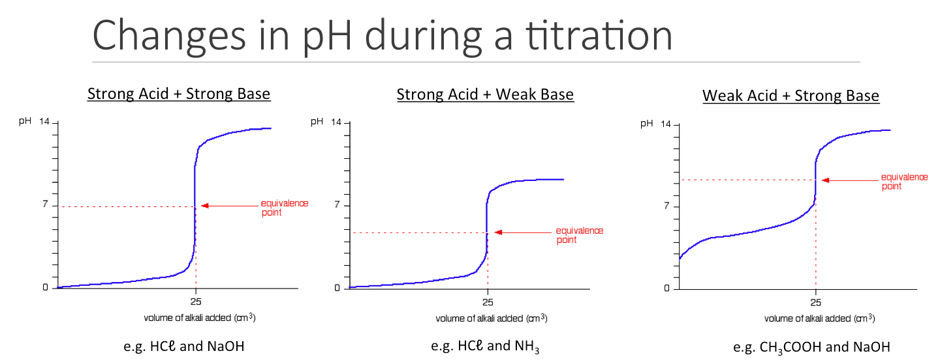

1. Complete the equation for each reaction.

HCℓ + NaOH → ………………………………………………

HCℓ + NH3 → ………………………………………………

CH3COOH + NaOH → ………………………………………………

1. The pH curves show that each reaction has a different equivalence point. Explain the differences in equivalence point for each of these reactions. Include relevant equations in your answer.  
    *Hint: This relates to something we learnt in Term 1 during the Acids & Bases topic…*

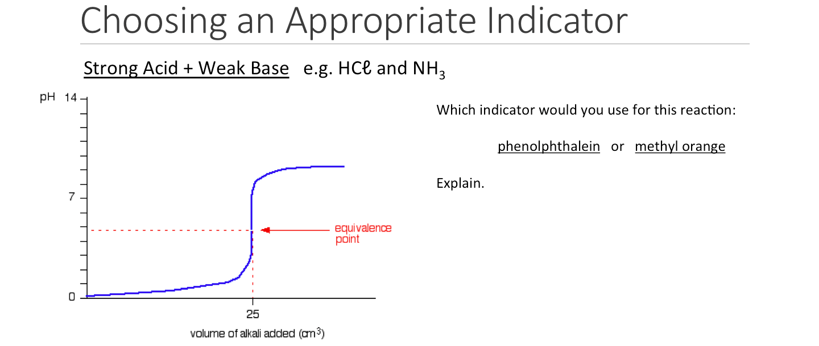

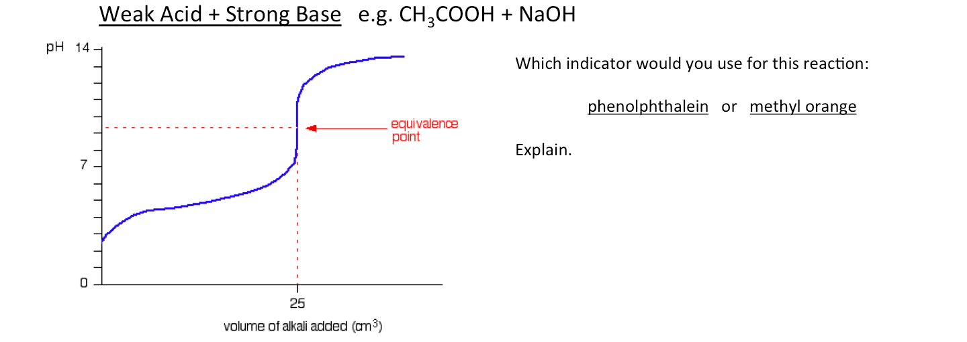

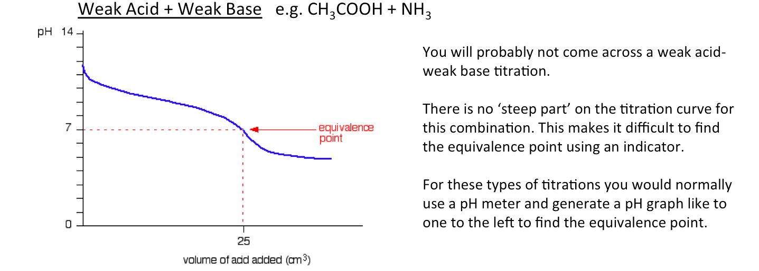

**SUMMARY:**

|  |  |  |
| --- | --- | --- |
| **Combination** | **Equivalence point** | **Appropriate indicator(s)** |
| Strong acid + Strong base | Neutral |  |
| Strong acid + Weak base | Acidic |  |
| Weak acid + Strong base | Basic |  |

**Rinsing**

During the previous experiment, you had to rinse certain glassware with certain solutions.

|  |  |
| --- | --- |
| **Step** | **Reason** |
| The pipette used to collect Na2CO3 was rinsed with a solution of Na2CO3 | If we had rinsed the pipette with water instead, then there would be some drops of water left in the pipette. This would have diluted the Na2CO3 solution.  Part of the calculation to find n(HCℓ) was calculating:  n(Na2CO3) = c x V  If the Na2CO3 had been diluted by water in the pipette then…   * There would be less moles of Na2CO3 in the flask * Less volume of HCℓ would need to be added to the flask * We would overestimate the concentration of HCℓ |
| The conical flask was rinsed with distilled water before the 20.00 mL of Na2CO3 was added | The purpose of the pipette was to collect exactly 20.00 mL of Na2CO3. We already know how many moles of Na2CO3 are in the pipette (n = c x V).  If we had rinsed the conical flask with Na2CO3 then…   * There would be excess moles of Na2CO3 in the flask * More volume of HCℓ would need to be added to the flask * We would underestimate the concentration of HCℓ   Adding extra water to the conical flask would not in any way affect the number of moles of Na2CO3, and would have no effect on the results. |
| The burette was rinsed with HCℓ | Similar to the pipette, if we had rinsed the burette with water then there would be some drops of water left in the burette. This would have diluted the HCℓ solution.  If the HCℓ solution was diluted then we would have needed a greater volume of HCℓ to react with the Na2CO3 solution. This means that we would have underestimated the concentration of HCℓ when calculating c(HCℓ) = n / V. |

As a general guideline:

* Pipettes, burettes and storage bottles are rinsed with the solution they will contain
* Conical flasks and volumetric flasks get rinsed with distilled water

It is important that you know what to rinse each piece of glassware with. One type of exam question might be to write a procedure for performing a titration. Your procedure should mention what each piece of glassware should be rinsed with.

Another type of exam question could be to explain the effects of incorrect rinsing procedures. Make sure that you understand the logic used in the above three examples, as this is the sort of mental working (and explanation) that you would need to be able to re-create in an exam.

**Errors**

In science, the word **error** does not mean the same thing as **mistake**. Experimental error means the difference between a **measurement** and the **true value**. All measurements have some form of error.

**Accuracy and precision**

* **Accuracy** refers to how close your value is to the true value.
* **Precision** refers to how consistent your results are.

The following image shows a depiction of accuracy and precision in archery.

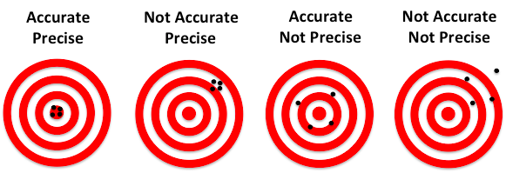

These concepts can be applied to titrations.

Imagine that for a particular titration, the correct titre volume is 18.21 mL.

The following are experimental results from three students:

|  |  |  |  |  |
| --- | --- | --- | --- | --- |
|  | **Titre Volume (mL)** | | | |
| **Trial 1** | **Trial 2** | **Trial 3** | **Average** |
| Student A | 17.64 | 17.67 | 17.66 | 17.657 |
| Student B | 17.04 | 18.20 | 17.33 | 17.523 |
| Student C | 18.23 | 18.21 | 18.23 | 18.223 |

How would you describe the **accuracy** and **precision** of the three students?

Student A is:

Student B is:

Student C is:

**Systematic errors**

Systematic errors cause your results to be **consistently higher** or **consistently lower** than the correct value.

Examples of systematic errors might be:

* Always using the wrong indicator
* Always rinsing the pipette or burette with water
* Always measuring from the top of the meniscus when using a pipette

Systematic errors could explain how Student A achieved results that were precise but inaccurate. e.g. perhaps every time they rinsed the pipette with water before using it, which diluted the solution going into the conical flask and meant they needed less volume of solution form the burette.

Most systematic errors in titrations can be eliminated with proper technique.

**Random errors**

Random errors cause **inconsistent results**. Sometimes it will make your answer **higher** than the correct value, and sometimes it will make your result **lower** than the correct value.

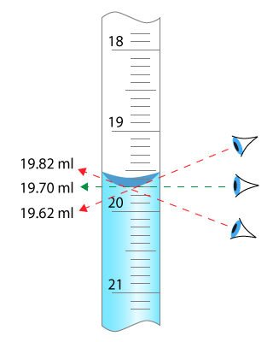

Some random errors are caused by user error. For example, volumes of solution should be read at eye-level, but someone might sometimes look from above eye-level and look from below eye-level. This means sometimes the measured volume would be too large and other times it would be too small.

Random errors can never be fully eliminated, even when using information with the correct technique. There are limitations to the accuracy of equipment itself and the ability of the people. Consider measuring burette volumes – there is a limit to how accurately you can read volumes using the scale on the burette.

**\*\*IF\*\*** all of the following equipment is used correctly…

* Burettes are able to measure volumes to the nearest 0.05 mL
* 250 mL volumetric flasks have a volume of 250.00 ± 0.12 mL
* 20 mL pipettes have a volume of 20.00 ± 0.06 mL
* A two decimal point mass balance can measure masses to nearest 0.01 g

The effects of random errors can be minimised by performing repeat trials, removing obvious outliers, and averaging the rest of the results.

**Dilutions**

Sometimes one of the solutions in a titration will be too concentrated, and will need diluting. In such cases you will often need to calculate the concentration of the original (undiluted) solution.

You can use the following formula to do this:

c1 and V1 are the concentration and volume of the original (undiluted) solution, and c2 and V2 are the concentration and volume of the diluted solution.

This can be rearranged to give:

**Example:**

A student analysed the ethanoic acid concentration in a commercial brand of vinegar. To do this, a 25.0 mL sample of the vinegar was diluted to 500.0 mL in a volumetric flask. 20 mL aliquots of the diluted vinegar were analysed by titration and found to have an ethanoic acid concentration of 0.0429 mol L-1. Determine the concentration of ethanoic acid in the original undiluted vinegar.

**Experiment: Ammonia content in household ammonia**

**Background:**

Household ammonia is a solution containing about 3% by mass of ammonia (about 2 mol L-1). In this experiment you will prepare a diluted solution of household ammonia and titrate it against your standardised HCℓ solution.

NH3(aq) + HCℓ(aq) → NH4+(aq) + Cℓ-(aq)

|  |  |
| --- | --- |
| **Equipment (Part A):**   * Household ammonia solution * 10 mL volumetric pipette * 50 mL beaker * Distilled water (300 mL) * Mass balance | **Equipment (Part B):**   * Standardised HCℓ solution * 20 mL volumetric pipette * Burette and stand * Funnel * Indicator (methyl orange or phenolphthalein) * 2x 100 mL beaker * 1x 50 mL beaker * 4x 250 mL conical flask |

**Procedure: Preparing the diluted NH3 solution**

1. Fill a beaker with 30 mL of household ammonia solution
2. Rinse a 10 mL pipette with the household ammonia solution
3. Rinse a 250 mL volumetric flask with distilled water.
4. Weigh the volumetric flask, then add 10.0 mL of household ammonia solution using the volumetric pipette. **Reweigh the volumetric flask before adding any water**.   
   *(This information will be used later to calculate the % by mass of ammonia)*

|  |  |
| --- | --- |
|  | Mass (g) |
| Empty vol. flask |  |
| Vol. flask + 10 mL household ammonia |  |
| 10 mL household ammonia (calculated) |  |

1. Fill the remainder of the flask with distilled water up to the mark. Invert the flask to mix.
2. *If this is happening in a different lesson to the next part of the procedure, you will need to store your diluted ammonia solution in a storage bottle. Rinse the storage bottle with some of the diluted ammonia solution before filling the bottle.*

**Procedure: Titrating the diluted ammonia solution vs. standardised HCℓ**

Perform the titration using 20.0 mL aliquots of diluted ammonia solution, with your standardised HCℓ solution in the burette. Prior to beginning the experiment, consider what you should use to rinse each piece of glassware in the experiment. Check with your teacher before proceeding.

|  |  |
| --- | --- |
| **Glassware** | **Rinse with…** |
| Burette |  |
| 20.0 mL pipette |  |
| Conical flask |  |

This will be a titration between a strong acid and a weak base. Which indicator will you use in this reaction?

_______________________________________

Perform a rough titration and then two to four additional titrations. Stop when you have three concordant titres.

|  |  |  |  |  |  |
| --- | --- | --- | --- | --- | --- |
| **Results:** | Rough estimate | Accurate titrations | | | |
| 1 | 2 | 3 | 4 (if needed) |
| Initial volume (mL) |  |  |  |  |  |
| Final volume (mL) |  |  |  |  |  |
| Titre volume (mL) |  |  |  |  |  |

**Calculations:**

Calculate the concentration of NH3 in the original (undiluted) ammonia solution (in mol L-1).

During the preparation of the diluted solution you should have measured the mass of 10.0 g of the original household ammonia solution. Using this value and your answer above, calculate the percentage by mass of NH3 in the household ammonia solution.

**Uncertainty Calculations (advanced)**

*This information is beyond the scope of the Year 12 Chemistry syllabus, however is useful additional information for high achieving students and/or those intending to pursue a Science degree at university.*

Uncertainty values are a measure of the random error inherent in equipment. For example, Class B pipettes can deliver of volume of 20.00 ± 0.06 mL. The “± 0.06 mL” is the uncertainty of the pipette. Regardless of how correctly you use the pipette, this is the limitation to its accuracy.

|  |  |
| --- | --- |
| **Equipment** | **Uncertainty** |
| 10.00 mL pipette | ± 0.01 mL *(Class A pipette)*  ± 0.02 mL *(Class B pipette)* |
| 20.00 mL pipette | ± 0.03 mL *(Class A pipette)*  ± 0.06 mL *(Class B pipette)* |
| Burette | ± 0.10 mL for a titre volume (final - initial)  (± 0.05 mL for *each reading)* |
| 250 mL volumetric flask | ± 0.12 mL |
| 500 mL volumetric flask | ± 0.20 mL |
| 2 decimal point mass balance | ± 0.01 g for measured mass (final - initial) |
| 3 decimal point mass balance | ± 0.001 g for measured mass (final - initial) |

**Percentage Uncertainty:**

Titrations involve the use of multiple measurements, each with its own uncertainty. To find out the overall uncertainty on the final calculation, we first need to convert each uncertainty to a percentage uncertainty.

For example, the percentage uncertainty for a 20.0 mL pipette = 0.06/20 x 100 = 0.3%

By summing the percentage uncertainty for each measurement, you get the overall percentage uncertainty for the calculated concentration.

**EXAMPLE:**

Joey performs a titration using NaOH and HCℓ. Before performing the experiment he dilutes the HCℓ by pipetting 20.00 mL into a 250 mL flask, and then makes the volume up to 250 mL. He adds this solution to the burette. He then pipettes 20.00 mL of NaOH into a conical flask, and performs the titration. It takes an average of 14.20 mL of HCℓ to neutralise the NaOH. From this, he calculates the concentration of HCℓ is 0.12572 mol L-1.

**What is the uncertainty in the concentration of HCℓ?**  
*Working on following page…*

Equipment Measurement Percentage uncertainty

Pipette HCℓ 20.00 ± 0.06 mL 0.30%

Vol. flask 250.00 ± 0.12 mL 0.048%

Pipette NaOH 20.00 ± 0.06 mL 0.30%

Titre volume 14.20 ± 0.10 mL 0.70%

Total: 1.348%

1.348% of 0.12572 is **0.002 mol L-1**. *(The uncertainty only gets written to 1 significant figure)*

Therefore, Joey should report his concentration as **0.126 ± 0.02 mol L-1.**In other words, the concentration of the HCℓ is between 0.124 mol L-1 and 0.126 mol L-1.

**Extension task:** Calculate the uncertainty of your Na2CO3 concentration, HCℓ concentration and your %mass of NH3 in the household ammonia.

**Part 1: Sodium carbonate solution**

|  |  |  |
| --- | --- | --- |
|  | **Measurement** | **Percentage uncertainty** |
| Mass of Na2CO3 |  |  |
| 500 mL vol flask | 500 ± 0.20 | 0.04% |
|  |  | **Total:** |

Concentration of sodium carbonate solution: ________________________________

**Part 2: Hydrochloric acid solution**

|  |  |  |
| --- | --- | --- |
|  | **Measurement** | **Percentage uncertainty** |
| Conc. of Na2CO3 |  |  |
| 20 mL pipette Na2CO3 |  |  |
| Titre volume HCℓ |  |  |
|  |  | **Total:** |

Concentration of HCℓ solution: ________________________________

**Part 3: Household ammonia solution**

|  |  |  |
| --- | --- | --- |
|  | **Measurement** | **Percentage uncertainty** |
| 10.0 mL conc NH3 |  |  |
| 250 mL vol flask |  |  |
| 20.0 mL dilute NH3 |  |  |
| Titre volume HCℓ |  |  |
| Concentration of HCℓ |  |  |
| Mass of 10 mL NH3 soln |  |  |
|  |  | **Total:** |

Percentage by mass of NH3 in household ammonia: ________________________________

*What was the biggest source of error in this experiment? How could it be minimised?*

***TITRATIONS PRAC TEST***

The titrations topic will be assessed over two lessons:

* A one hour **practical test** that will assess your ability to correctly perform a titration. You will be marked based on your experimental results and how closely they match the expected results.
* A one hour **written test** that will assess your broader understanding of volumetric analysis, including both explanation-type questions and calculation-type questions. One of the calculation-type questions will be related to your practical test. The style of questions in this assessment will be similar to those in past exam papers.

|  |  |
| --- | --- |
| **Component** | **Weight of yearly mark** |
| Part 1: Practical skills | 2.0% |
| Part 2: Written questions | 4.0% |
| **Total** | **6.0%** |

**Practical test details:**

The practical test will be run on the date shown on the **front cover of this booklet**. For the larger class, the practical test will run over two lessons.

The practical test will require you to prepare a diluted vinegar solution and titrate it against a standardised solution of NaOH. You will be assessed on the quality and accuracy of your results. Your accuracy will be based on how closely your results align to mine (Mr McKenna’s). I will perform the same titration with the same solutions. You will receive points based on how close your titre volumes are to my own titre volumes. If your titre volumes fall within the same uncertainty range as mine then you will receive full marks for accuracy. Marks will decrease as you become further away from my score.

**Example:**

Mr McKenna has a titre volume of 17.2 ± 0.2 mL

Student A has a titre volume of 17.1 ± 0.2 mL …………… Full marks for Student A

Student B has a titre volume of 17.6 ± 0.2 mL …………… Full marks for Student B  
 *(as perhaps the ‘true’ value is 17.4 mL)*

Student C has a titre volume of 16.5 ± 0.2 mL …………… Not full marks for Student C

The only calculation you will need to do is to calculate your average titre volume. You will **not** need to perform any other calculations during the practical lesson, however there will be calculation questions on the written test related to this experiment.

**The front page of the practical test is shown to the right.**

**PRACTICAL TEST – TITRATIONS**

|  |  |
| --- | --- |
| **Section** | **Marks** |
| Can fill volumetric flask up to the line | / 1 |
| Can consistently reach an end point | / 2 |
| Can accurately use a 20.0 mL pipette | / 3 |
| Accuracy and precision of titre volumes | / 9 |
| **TOTAL:** | **/ 15** |

***Overview:***

In this practical test you will prepare a diluted solution of acetic acid from commercial vinegar. The acetic acid will be titrated against standardised sodium hydroxide.

**Solutions supplied:**

* A standardised solution of NaOH (150 mL)
* Commercial vinegar solution (50 mL - undiluted)
* Phenolphthalein indicator
* Distilled water

**Supplied equipment:**

* 250 mL volumetric flask
* 3x 100 mL beaker (for storing NaOH, conc. vinegar, dilute vinegar)
* 1x 50 mL beaker (waste)
* 20 mL volumetric pipette and filler
* Conical flasks
* Burette and stand
* Funnel

~~~~~~~~~~~~~~~~~~~~~~~~~~~~~~~~~~~~~~~~~~~~~~~~~~~~~~~~~~~~~~~~~~~~~~~~

**Part 1: Dilution of vinegar**

Commercial vinegar is much more concentrated than the sodium hydroxide we will use, so it will require dilution before it can be titrated. Use the provided volumetric pipette and volumetric flask to prepare a diluted vinegar solution.

***IMPORTANT:*** *During this titration you will need to show the teacher a volumetric flask with 250.0 mL of solution. It is recommended that you do this while making up your solution during Part 1. Show the full volumetric flask before inverting the flask as some of the liquid will stick to the stopper during the inversion process.*

**Part 2: Titration against sodium hydroxide**

This titration will be performed with the sodium hydroxide solution in the burette and 20 mL of diluted vinegar in a conical flask. Perform a number of titrations until you have achieved consistent results.

***IMPORTANT:*** *During this titration you will need to show the teacher two conical flasks which are at the correct endpoint for your chosen indicator. You should show both conical flasks at the same time so that the consistency of your endpoint can be evaluated.*

**TITRATION CALCULATIONS**

**Question 1:**

A titration was performed using 20 mL aliquots of NaOH and a standardised solution of 0.1442 mol L-1 HCℓ. The NaOH required 16.45 mL of HCℓ to be neutralised. Find the concentration of the NaOH solution.

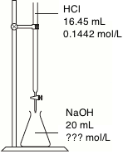

HCℓ + NaOH 🡪 NaCℓ + H2O

***HINT 1:*** *Sketches like the one to the right can be really useful in making sure you understand what is happening.*

***HINT 2:*** *Always start by working with the ‘known’ substance. In this case, find the moles of HCℓ.*

A: 0.1186 mol L-1

**Question 2:**

A titration was performed using 20 mL aliquots of nitric acid (HNO3), with 0.2201 mol L-1 KOH in the burette. Three titrations were performed, with an average titre volume of 12.20 mL. Calculate the concentration of the nitric acid.

KOH + HNO3 🡪 KNO3 + H2O

A: 0.1343 mol L-1

**Question 3:**

A solution of NaOH was standardised by reacting with a 0.1008 mol L-1 solution of H2SO4. An average volume of 18.64 mL of sulfuric acid was required to neutralise the 20.00 mL aliquots of NaOH. Find the concentration of NaOH.

H2SO4 + 2 NaOH 🡪 Na2SO4 + 2 H2O

***HINT:*** *This problem is different from the others because sulfuric acid is a* ***diprotic acid****. There is a 2:1 mole ratio between H2SO4 and NaOH. n(NaOH) = 2 x n(H2SO4).*

A: 0.1879 mol L-1

**Question 4:**

A solution of phosphoric acid (H3PO4), a triprotic acid, was standardised by reacting with a 0.08555 mol L-1 solution of NaOH. An average volume of 27.55 mL of phosphoric acid was required to neutralise the 20.00 mL aliquots of NaOH. Find the concentration of phosphoric acid.

H3PO4 + 3 NaOH 🡪 Na2SO4 + 2 H2O

***HINT:*** *Once again, be careful of the mole ratio. It is not 1:1.*

A: 0.02070 mol L-1

**Question 5:**

The main ingredient in vinegar is acetic acid (CH3COOH), a monoprotic acid. A solution of acetic acid was standardised by reacting with a 0.09782 mol L-1 solution of NaOH. An average volume of 18.64 mL of NaOH was required to neutralise the 20.00 mL aliquots of CH3COOH. Find the concentration of acetic acid.

***HINT:*** *No equation was written for this reaction. You should write a balanced reaction to find the mole ratio.*

A: 0.09117 mol L-1

**Question 6:**

The main ingredient in wine is tartaric acid (C4H6O6), a diprotic acid. A solution of tartaric acid was standardised by reacting with a 0.1024 mol L-1 solution of NaOH. An average volume of 18.64 mL of tartaric acid was required to neutralise the 20.00 mL aliquots of NaOH. Find the concentration of tartaric acid.

A: 0.05494 mol L-1

**Question 7:**

A titration was performed using 20 mL aliquots of 0.04056 mol L-1 solution of sodium carbonate. The sodium carbonate was titrated against a solution of nitric acid with a concentration of approximately 0.1 mol L-1. The following information was recorded for the titration.

|  |  |  |  |  |
| --- | --- | --- | --- | --- |
|  | Volume of HNO3 solution required | | | |
| 1 | 2 | 3 | 4 |
| Initial volume (mL) | 0.45 | 1.20 | 0.05 | 12.40 |
| Final volume (mL) | 20.80 | 20.40 | 19.25 | 31.65 |
| Titre volume (mL) | 20.35 | 19.20 | 19.20 | 19.25 |

Calculate the concentration of the nitric acid solution.

***Hint:*** *You will need to calculate the average titre volume to use in your calculation. Don’t include any outliers in your average. Only include concordant (consistent) values. i.e. within ± 0.1 mL.*

A: 0.08443 mol L-1

**Question 8:**

A solution of sodium hydroxide was standardised by titrating against 1.067 mol L-1 H2SO4. The titration was performed using 20 mL aliquots of H2SO4 with the NaOH in the burette. The following information was recorded for the titration:

|  |  |  |  |  |  |
| --- | --- | --- | --- | --- | --- |
|  | Volume of NaOH solution required | | | | |
| 1 | 2 | 3 | 4 | 5 |
| Initial volume (mL) | 0.20 | 1.65 | 1.60 | 17.20 | 12.40 |
| Final volume (mL) | 17.85 | 18.05 | 17.90 | 36.15 | 28.70 |
| Titre volume (mL) |  |  |  |  |  |

Calculate the concentration of the sodium hydroxide solution.

A: 2.613 mol L-1

**Question 9:**

A solution of household ammonia was analysed by titration to determine the concentration of ammonia in the solution. Prior to analysis, the ammonia was **diluted** by pipetting a 10.00 mL aliquot into a 500 mL volumetric flask and making up to the mark using distilled water. The titration was then performed using 20.00 mL aliquots of the **diluted** ammonia solution in the conical flask, and 0.07844 mol L-1 hydrochloric acid in the burette.

The following information was recorded for the titration:

|  |  |  |  |  |
| --- | --- | --- | --- | --- |
|  | Volume of HCℓ solution required | | | |
| 1 | 2 | 3 | 4 |
| Initial volume (mL) | 0.75 | 7.20 | 4.30 | 4.95 |
| Final volume (mL) | 23.40 | 29.80 | 26.30 | 27.50 |
| Titre volume (mL) |  |  |  |  |

Calculate the concentration (in mol L-1) of ammonia in the **original (undiluted)** solution.

***HINT:*** *First, calculate the concentration of diluted ammonia using information about the titration. Then you can use the formula c1 x V1 = c2 x V2 to calculate the concentration of the undiluted ammonia solution.*

A: 4.432 mol L-1

**Question 10:**

A solution of vinegar was analysed by titration to determine the concentration of acetic acid. Prior to analysis, the vinegar was diluted by pipetting a 25.00 mL aliquot into a 250 mL volumetric flask and making up to the mark using distilled water. The titration was then performed using 20.00 mL aliquots of the 0.1005 mol L-1 NaOH in the conical flask, and diluted vinegar in the burette.

The following information was recorded for the titration:

|  |  |  |  |  |
| --- | --- | --- | --- | --- |
|  | Volume of diluted CH3COOH solution required | | | |
| 1 | 2 | 3 | 4 |
| Initial volume (mL) | 0.25 | 4.55 | 12.60 | 6.60 |
| Final volume (mL) | 20.30 | 24.25 | 32.30 | 26.20 |
| Titre volume (mL) |  |  |  |  |

Calculate the concentration (in mol L-1) of acetic acid in the vinegar.

A: 1.022 mol L-1

**Question 11:**

A solution of Na2CO3 was prepared by dissolving an unknown mass of anhydrous Na2CO3 into 250.0 mL of water. 20.00 mL aliquots of the resulting solution were titrated against 0.09835 mol L-1 HCℓ. The average titre volume was 25.87 mL.

Calculate the mass of Na2CO3 dissolved in the volumetric flask.

***HINT:*** *Use your normal titration calculations to find the number of moles of Na2CO3 in the conical flask, and then from this find the number of moles of Na2CO3 in the volumetric flask.*

*Remember, a simple diagram of the steps can aid in understanding what is happening.*

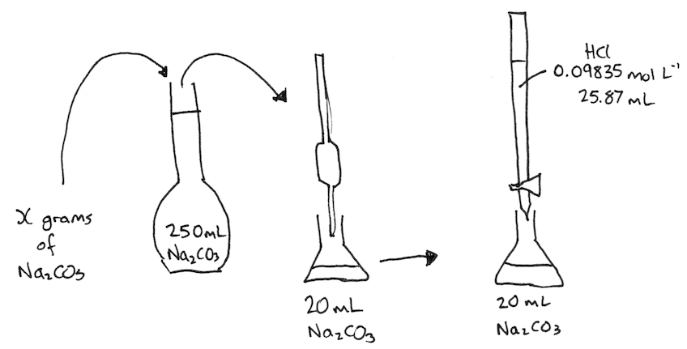

A: 1.685 g

**Question 12:**

A solution of oxalic acid (H2C2O4) was prepared by dissolving an unknown mass of oxalic acid dihydate (H2C2O4.2H2O) in a 500 mL volumetric flask. The oxalic acid was placed in the burette, and was titrated against 20.00 mL aliquots of 0.007930 mol L-1 NaOH solution. The average titre volume was 22.40 mL.

Calculate the mass of oxalic acid dihydrate dissolved in the 500 mL volumetric flask.

**Note:** Oxalic acid (H2C2O4) is a diprotic acid.

***HINT:*** *Use your normal titration calculations to find the number of moles of H2C2O4 in the 22.40 mL titre volume, and from this find the number of moles of H2C2O4 in the volumetric flask.*

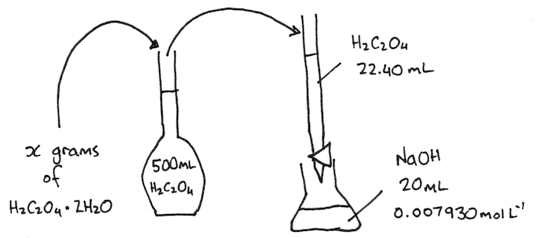

A: 0.2232 g

**Question 13:**

Washing soda is an impure mixture which mainly contains sodium carbonate decahydrate (Na2CO3.10H2O).

4.81 g of washing soda was dissolved in 500 mL of water and the flask was inverted multiple times to ensure thorough mixing. 20.00 mL aliquots of this solution were then titrated against 0.06544 mol L-1 hydrochloric acid using methyl orange indicator. An average titre volume of 18.45 mL was required to reach the end point.

Calculate the percentage by mass of sodium carbonate decahydrate in the washing soda sample.

***HINT:*** *You will need to find the mass of Na2CO3.10H2O in the sample using information from the titration, and then use the following formula:*

A: 89.8%

**Question 14:**

Potassium hydroxide (KOH) cannot be used as a primary standard because it is deliquescent (absorbs water moisture from the air).

A solution of potassium hydroxide was prepared by dissolving 1.32 g of potassium hydroxide pellets in a 250 mL volumetric flask. A small amount of the solution was used to rinse a burette, and then the burette was filled with the potassium hydroxide solution.

Separately, 20.00 mL aliquots of 0.09667 mol L-1 HCℓ were pipetted into clean conical flasks, and 2-3 drops of bromothymol blue indicator was added. KOH solution was added until the bromothymol blue changed colour from yellow to green. On average, 20.97 mL of KOH solution was required to reach the end point.

Calculate the %KOH and %H2O in the potassium hydroxide pellets used to make the KOH solution.

A: 98.0%, 2.0%

**Question 15:**

The acidity of wine is due mainly to potassium tartrate (cream of tartar), a weak monoprotic acid with a molar mass of 188 g mol-1. Three 50 mL samples of wine were titrated with 0.012 mol L-1 NaOH. The results of the titrations are shown below:

|  |  |  |  |  |
| --- | --- | --- | --- | --- |
|  | Volume of NaOH solution required | | | |
| 1 | 2 | 3 | 4 |
| Initial volume (mL) | 0.0 | 0.0 | 0.0 | 0.1 |
| Final volume (mL) | 12.65 | 9.70 | 10.10 | 10.20 |
| Titre volume (mL) | 12.65 | 9.70 | 10.10 | 10.10 |

1. Calculate the moles of potassium tartrate in 50 mL of wine
2. Calculate the concentration of potassium tartrate in g L-1.

***HINT:*** *Even though you don’t have the chemical formula for potassium tartrate, the question stated that it is monoprotic and provided the molar mass, which is all that you need to solve the question. To answer part (b), first find the mass of potassium tartrate in 50 mL of the wine, and then divide this by the volume (in litres).*

(a) 0.0228 g; (b) 0.456 g L-1

**Question 16:**

A solution of household vinegar was analysed to determine the acetic acid content. 10.00 mL of vinegar was added to a 250 mL volumetric flask and distilled water was added until the total volume of the solution was 250 mL. 20.00 mL aliquots of the diluted vinegar solution were pipetted into clean conical flasks, and 2-3 drops of phenolphthalein was added.

On average, 16.70 mL of 0.0500 mol L-1 NaOH was required to neutralise the 20.00 mL aliquots of diluted vinegar.

1. Calculate the mass of CH3COOH in 10 mL of the original undiluted vinegar
2. Given that the density of household vinegar is 1.05 g/mL, calculate the percentage by mass of acetic acid in the household vinegar.

***HINT:*** *You should be able to solve part (a) using skills you have developed through other questions. For part (b), you are going to need to use the formula:*

*You will need to use the density to figure out the mass of 10 mL of undiluted vinegar. The equation for density is…*

*By rearranging this equation you should be able to calculate the mass of 10 mL of vinegar.*

(a) 0.0104 g; (b) 5.97%

**Question 16:**

A chemist analysed aspirin tablets for quality control. The initial step of the analysis was the standardisation of a NaOH solution. Three 25.00 mL samples of a 0.1034 mol L-1 solution of standardised HCℓ were titrated with the NaOH solution. The average volume required for neutralisation was 25.75 mL.

Three conical flasks were prepared each containing a mixture of 25 mL of water and 10 mL of ethanol. One aspirin tablet was dissolved in each flask. The aspirin in each solution was then titrated with the standardised NaOH solution according to the following equation:

C9H8O4(aq) + NaOH(aq) 🡪 C9H7O4Na(aq) + H2O(ℓ)

aspirin

The following titration results were obtained.

|  |  |
| --- | --- |
| Tablet | Volume of NaOH (mL) |
| 1 | 16.60 |
| 2 | 16.50 |
| 3 | 16.55 |

Calculate the average mass (in mg) of aspirin in each tablet.

***HINT:*** *There are two titrations here. Start by finding the c(NaOH) using the HCℓ titration.*

A: 299 mg

**Question 17:**

A student was asked to determine the mass, in grams, of calcium carbonate present in a 0.125 g sample of chalk. The student placed the chalk in a 250 mL conical flask and added 50.00 mL of 0.200 mol L-1 HCℓ using a volumetric pipette. The solution was stirred until no further reaction occurred.

The student then titrated the excess HCℓ against 0.250 mol L-1 NaOH. The average NaOH titre volume was 32.12 mL.

Calculate the mass of calcium carbonate, in grams, present in the chalk sample.

***HINT:*** *This strategy is called a ‘back titration’. From the first paragraph you can calculate the n(HCℓ) that were initially added to the flask. Some of this HCℓ would have reacted with the calcium carbonate, but some was left over. The n(HCℓ) left over was measured in the NaOH titration.*

*n(HCℓ reacted) = n(HCℓ initial) – n(HCℓ excess)*

*Find out how many moles of HCℓ reacted with the calcium carbonate, and use that to figure out how much calcium carbonate was in the chalk.*

A: 0.0986 g

**Question 18:**

US federal regulations set the upper limit of ammonia (NH3) in air in a work environment of 38.5 µg (38.5 x 10-6 g) per litre of air. To test the air quality in a manufacturing plant, 100.0 L of air was bubbled through 100 mL of 0.0105 mol L-1 HCℓ.

10.0 mL aliquots of the reacted mixture is then titrated with 0.00588 mol L-1 NaOH. On average, 13.10 mL of NaOH was required to neutralise the excess HCℓ.

Calculate the concentration of ammonia in the air sample (in µg/L) and state whether or not the manufacturer is in compliance with regulations.

***HINT:*** *This is another back titration. Figure out how many moles of HCℓ must have reacted with the NH3, and use that to find out how much NH3 was in 100.0 L of air.*

A: 48.6 µg/L, no

**HOMEWORK:**

|  |  |  |
| --- | --- | --- |
| **Source** | **Set/Chapter** | **Questions to complete** |
| This workbook | Calculation questions  (pg. 24-39) | 1 2 3 4 5 6 7 8 9 10 11 12 13 14 15 16 17 18 |
| Essential Chemistry | Set #7 (pg. 60-63) | 1 2 3 4 5 6 7 8 9 10 11 12 13 14 15 16 17 18 |
| Past exam questions | | Page… 2 3 4 5 6 7 8 9 10 11 12 13 14 15 16 17 18 19 20 21 22 23 24 25 26 27 28 |